
eNHIS Data Capture Workshop
Introduction to eNHIS data capturing, reporting & data visualization

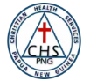
PREPARED BY: JERRY KAINO
DATA PROCESSING OFFICER
CHSPNG HEALTH SERVICES & PROGRAMS
Learning Outcome:
- Participants will be able to explain the importance of accurate data capture in eNHIS for Papua New Guinea's healthcare system.
- Participants will be able to describe how data templates are used within eNHIS to ensure consistent and standardized collection of specific health information for CHSPNG.
- Participants will be able to identify different types of data templates used in eNHIS
eNHIS Data Capture Workshop – Standardizing Health Information in PNG
Target Audience: Healthcare workers involved in Health Mangers, Health Information Officer, Data Entry Officer, HEO

Materials:
- Projector and screen (Smart phones)
- Whiteboard or flipchart markers
- Handouts with key information and visuals (e.g., definitions, benefits of eNHIS, data capture templates)

Duration: 6 hours
Welcome and Introductions  (15 mins) | - Introduce facilitators and participants.  - Briefly discuss workshop objectives and agenda.
The Power of Data for Public Health (30 mins) | - Explain the importance of data collection and analysis in healthcare delivery.  - Discuss the limitations of traditional paper-based records.  - Highlight the benefits of electronic health information systems.
Introduction to eNHIS  (45 mins) | - Introduce eNHIS and its functionalities.  - Discuss the benefits of eNHIS for data accuracy, efficiency, and accessibility.  - Walk participants through the eNHIS user interface (using screenshots or a simulated environment).
Tea Break (15 mins)
Steps to Retrieve Data from eNHIS (45 mins) | - Provide a step-by-step guide on accessing eNHIS.  - Demonstrate how to navigate the system for data retrieval relevant to health agencies reporting.  - Discuss functionalities like filtering data by location health facilities, aid post, clinics and date range.
Hands-on Exercise: Retrieving Data for Monthly Reporting (45 mins) | - Participants will practice retrieving data for a mock monthly report using the simulated eNHIS environment.  - Facilitate group discussion and address any challenges faced during the exercise.
Lunch Break (1 Hour)
Advanced Data Retrieval  (45 mins) | - Discuss functionalities for retrieving data beyond routine monthly reports (e.g., specific disease trends).  - Introduce concepts like data export for further analysis in spreadsheets or data visualization tools.
Q&A Session (30 minutes) | - Address any questions or concerns participants may have regarding eNHIS access, data retrieval, or reporting procedures.
Wrap-up and Conclusion  (15 minutes) | - Briefly summarize key learning points and workshop takeaways.  - Discuss the importance of ongoing data capture and reporting accuracy through eNHIS.  - Provide resources for further learning and technical support regarding eNHIS

Table of Content
What is the Electronic National Health Information System (eNHIS)?
- Introduction: Purpose and Benefits of eNHIS
- How eNHIS Works: Data Collection and Utilization
- Advantages of eNHIS over Traditional Methods
- Challenges of Implementing eNHIS
Why is eNHIS Data Capturing Important?
- Significance of Accurate and Complete Data Capture
- Benefits of Reliable Data for Decision-Making
- Monitoring Health Trends, Resource Allocation, Program Evaluation
Introduction to Data Templates
- Definition and Purpose of Data Templates
- Types of Data Templates
- Advantages of Using Data Templates
Understanding the Data Capture Template
- Breakdown of Template Sections (Data Category, Variable, eNHIS Data Source, Definition, Capture Method)
- How to Utilize the Template (Identifying Needs, Filling the Template, Documenting Capture Method)
Data Retrieval/Capture and Submission Process
- Monthly Reporting Requirements for Health Agencies
- Data Retrieval Steps within eNHIS
- Optional Data Analysis by Health Agencies
- Accessing eNHIS: A Guide for Health Agency
- Data Submission Procedures to CHSPNG Head Office
Summary
- Workshop Objectives: Equipping Health Agencies for Effective Data Capture
- Importance of Accurate Data Submission Through eNHIS
- Exploring the eNHIS Platform and Data Categories
- Utilizing Data Capture Templates for Efficient Data Collection
- Ensuring Data Quality and Completeness through Best Practices
- Addressing Common Challenges During Data Capture and Submission
Wrap-up and Next Steps
- Key Learnings and Workshop Recap
- Hands-on exercise
- Ongoing Support and Resources for Health Agencies

Introduction
Welcome, Christian Health Agency (CHA) personnel! We are thrilled to have you participate in this workshop on empowering effective data capture for improved public health in Papua New Guinea.

Papua New Guinea's healthcare system relies heavily on the dedication and expertise of health agency. You play a vital role in delivering essential health services to communities across the country. However, effective healthcare delivery depends on strong data collection and analysis. Traditionally, paper-based records made data collection cumbersome and limited the ability to track trends or identify areas needing improvement.
The electronic National Health Information System (eNHIS) represents a significant leap forward. This secure online platform allows health agency to electronically retrieve and capture data on existing online database which have information on patients, diagnoses, services provided, and other health indicators. This workshop will equip you with the knowledge and skills to navigate eNHIS effectively, maximizing its potential for improved public health outcomes.

Objectives and Goals
This workshop aims to achieve the following objectives:
- Enhance your understanding of the importance of data collection for public health improvement.
- Introduce you to the functionalities of eNHIS and its benefits for Health Agencies.
- Equip you with the skills to confidently access and retrieve data from eNHIS for essential reporting needs.
- Empower you to utilize eNHIS for data analysis beyond routine reporting (Optional)

Throughout this workshop, you will gain a comprehensive understanding of:
- The eNHIS system and its significance for public health in Papua New Guinea.
- Different sections of the eNHIS platform for efficient data capture.
- Effective techniques for data entry and submission using various data field types.
- Best practices for maintaining data quality and completeness.
- Troubleshooting methods to overcome common challenges faced during data capture.
Get Ready to Engage!
This workshop will combine presentations, interactive exercises, and hands-on practice using a simulated eNHIS environment. We encourage active participation and open discussions throughout the session. Our dedicated facilitators are here to answer your questions and guide you through the exciting world of eNHIS for Health Agencies.
Let's embark on this journey of empowering data capture and building a healthier future for Papua New Guinea, together!

What is the Electronic National Health Information System (eNHIS)?
The eNHIS stands for Electronic National Health Information System. It's a digital system designed to modernize Papua New Guinea's healthcare sector by managing health data electronically.
In simpler terms, instead of relying on paper records, eNHIS uses computers to collect and store important health information. This information can include things like:
- Patient details (name, age, medical history)
- Doctor's visits and diagnoses
- Prescriptions and medications
- Lab test results

This digital system offers several advantages over traditional paper-based methods.
Improved Accuracy and Efficiency | - With eNHIS, healthcare providers can access and update patient information quickly and easily. This reduces the risk of errors that can occur with handwritten records and saves time spent managing paperwork.
Better Tracking of Health Trends | - eNHIS allows for the collection and analysis of vast amounts of health data across the country. This helps identify trends in diseases, track outbreaks, and understand the overall health needs of the population.
Informed Decision Making | - By having better data on patient health and trends, policymakers and healthcare providers can make more informed decisions.

- Limited internet connectivity in some remote areas can hinder site surfing.
- Requires ongoing training for health workers on data collection procedures and using the eNHIS system.
- Data analysis and interpretation capabilities need to be strengthened to fully utilize the collected information
Challenges:

Why eNHIS Data Capturing is Important?
Accurate and complete data capture is essential for the eNHIS to function effectively. Think of eNHIS as a giant puzzle – each piece of patient information you enter is like a puzzle piece. The more complete the data, the clearer the overall picture of the country's health becomes.
Here's why capturing accurate and complete data is crucial:
Reliable Information for Decision-Making:
- Incomplete or inaccurate data can lead to misleading information. With eNHIS, healthcare professionals, policymakers, and researchers rely on this data to make important decisions about public health.
Monitoring Community Health:
- eNHIS allows us to track health trends across different communities. This can help identify areas with higher rates of specific diseases or those lacking access to certain healthcare services.
Targeted Resource Allocation:
- By understanding where the greatest healthcare needs are, resources like medications, equipment, and personnel can be allocated more effectively.
Program Evaluation:
- Public health programs rely on data to measure their effectiveness. eNHIS data can help us see if these programs are achieving their goals and identify areas for improvement.
In essence, accurate data capture in eNHIS is like having a clear picture of the country's health. This allows us to better understand the needs of our communities, allocate resources efficiently, and ultimately improve the health of everyone in Papua New Guinea.

Introduction to Data Templates
Now that we understand the importance of accurate data capture in eNHIS, let's explore how we collect this information. Here, data templates come into play.
Data templates are like standardized forms within eNHIS on CHSPNG interests. They provide a consistent way to collect specific types of health information. Imagine them as pre-defined boxes on a form, each with a clear label telling you what information to enter. This ensures that everyone entering data uses the same format and captures the same essential details.
There are 2 main different types of data templates that are designed for various purposes to capture specific data essential for CHSPNG data collection for monitoring & evaluation reasons:
- Quarterly Review Data Template:
These templates might focus on specific health indicators or program performance and are typically completed every three months.
- Monthly Data Template:
These capture routine information, such as the number of patient visits or medication dispensed, on a monthly basis.
- Specific Health Indicator:
These templates are designed to collect data on specific health concerns, like diabetes or malaria, to monitor their prevalence and trends.

Benefits of data templates:
Consistency: | Guarantee a uniform presentation of data across different platforms or reports.
Efficiency: | Save time and effort by pre-defining the structure for data entry, retrieval, and display.
Reusability: | Can be reused for similar data sets, reducing the need to create new layouts from scratch.
Reduce Errors: | Define specific data types for each field, minimizing the chance of entering invalid information.

There are several key reasons why Health Agencies in Papua New Guinea capture and retrieve data from the eNHIS (electronic National Health Information System) on a monthly basis:
Monitor Health Trends: | - Monthly data collection allows for tracking changes in health indicators over time. This helps identify emerging trends, such as increases in specific diseases, changes in immunization rates, or shifts in demographics utilizing health services.  - By monitoring trends, CHSPNG (Christian Health Services PNG) and the National Department of Health can proactively address public health concerns and allocate resources effectively.
Early Detection of Outbreaks: | - Timely reporting of infectious diseases is critical for containing outbreaks. Monthly data allows for early  - identification of potential outbreaks by detecting sudden spikes in cases of specific illnesses.  - This enables rapid intervention with public health measures like contact tracing, vaccination campaigns, or community awareness initiatives.
Inform Decision Making: | - The data collected from health agencies provides valuable insights into healthcare needs across the country. This information is crucial for:  - Resource Allocation:  - Deciding how to best allocate resources like medications, medical equipment, and healthcare personnel across various regions.  - Policy Development:  - Formulating effective health policies and strategies to address priority public health issues.  - Program Evaluation:  - Assessing the effectiveness of existing health programs and interventions.
Improved Service Delivery: | - By analysing monthly data, Health Agencies can identify areas within their jurisdiction where healthcare services might need improvement.  This data can inform decisions on:  - Expanding services in areas with high demand.  - Tailoring outreach programs to address specific health needs of a community.  - Improving referral systems for patients requiring specialized care.
Accountability and Transparency: | - Regular data submission by Health Agencies ensures transparency and accountability in the healthcare system.  - The data allows CHSPNG to monitor the performance of Health Agencies with its facilities and ensure they are delivering essential health services to the communities they serve.

Overall, monthly data collection and retrieval from Health Agencies through eNHIS plays a vital role in strengthening Papua New Guinea's health system. It provides valuable insights for monitoring health trends, responding to outbreaks, informing decision-making, and ultimately improving healthcare delivery for the population.

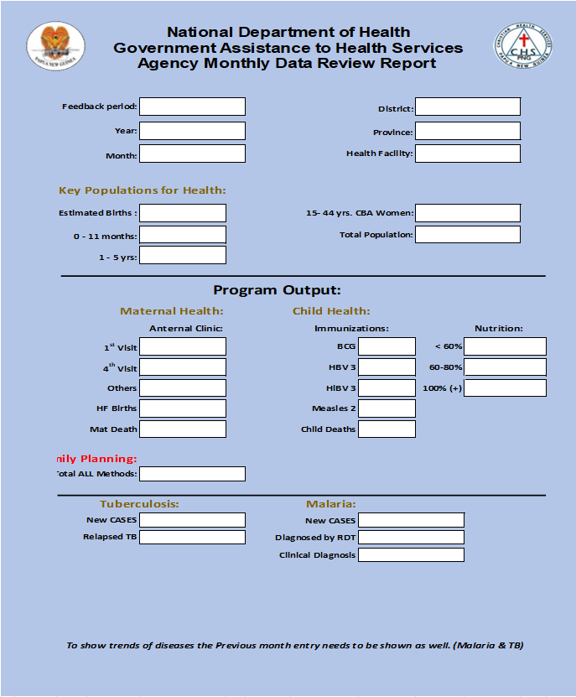
Figure: 0.1. monthly data capture template

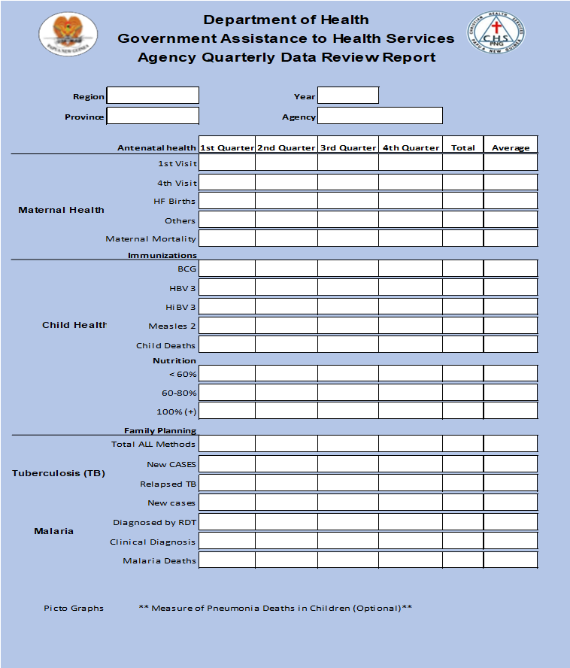
Figure: 1.1. Quarterly data template

Understanding the Data Capture Template
This data capture template is your key tool to efficiently collect specific information from the eNHIS system. It will help you organize and record the data points most relevant to your needs.

Here's a breakdown of the template's potential sections:
Data Category | This will help you classify the type of data you're capturing (e.g., demographics, health indicators, program participation
Variable | This refers to the specific data point you're interested in within a category (e.g., age, gender, program enrolment date).
eNHIS Data Source | Here you'll note the specific section or module within eNHIS where you can locate the desired data point. This might involve
Data Definition | Briefly define the variable to ensure clarity. For instance, if you're capturing "age," specify if it's recorded in years or months.
Data Capture Method | Describe the steps involved in extracting the data from eNHIS. This could involve using filters, exporting data to spreadsheets, or making calculations based on existing data points

These templates offer several advantages, including:
- Improved organization and clarity for data collection monitoring & Monitoring.
- Increased efficiency by providing a clear roadmap for retrieving data.
- Reduced risk of errors through clear data definitions and capture methods.
- Enhanced collaboration by allowing healthcare workers to share their data capture strategies with the agency and organization.

How to Use the Template:
- Identify your data needs | What specific information are you trying to capture from eNHIS?
- Fill in the template | For each data point you need, identify the category, variable, eNHIS source, and define it clearly.
- Document the capture method | Outline the steps involved in retrieving the data from eNHIS.
- Utilize the notes section | Add any specific details or considerations for capturing that specific data point.

Data Retrieval/Capture and Submission Process:
- Monthly Reporting:
All Health Agencies are required to log in to the eNHIS (electronic National Health Information System) on a monthly basis.
- Data Retrieval:
Once logged in, health agency’s personnel can access and retrieve relevant health data for their specific facility or area of operation.
- Data Analysis (Optional):
While data submission is the primary task, Health Agencies might also perform basic data analysis to identify trends or areas requiring attention within their jurisdiction.
- Data Submission:
The retrieved data from eNHIS needs to be submitted to the CHSPNG head office. This could involve uploading the data through a designated online portal or potentially using a separate reporting format required by CHSPNG

Accessing eNHIS: A Guide for Health Agency
This User manual guide provides a general overview of accessing the eNHIS (electronic National Health Information System) platform. Due to the secure nature of eNHIS and potential variations in the interface, some details might differ slightly depending on your specific user role and system updates.

What You'll Need:
- A computer with internet access
- A valid eNHIS username and password provided by CHSPNG Head Office
Accessing the eNHIS Platform:
- Launch your web browser: Open a preferred web browser like Google Chrome, Mozilla Firefox, or Microsoft Edge.
- Navigate to the eNHIS Login Page: Use the designated website address provided by CHSPNG Head Office. This address might be a specific URL or a web portal login page within the national health department's website.

3. Enter Login Credentials:
- Username: Enter the username assigned to you by CHSPNG for eNHIS access.
- Password: Enter your secure password for eNHIS.
- Login: Click the "Login" button or press "Enter" on your keyboard to proceed.

Once Logged In:
- You will be directed to the eNHIS home screen. The layout and functionalities might vary depending on your user role and access permissions.
- Familiarize yourself with the navigation menu options available. These might include sections for "Reports," "Data Retrieval," "Data Entry" (for authorized users), and "User Settings."

Important Notes:

Security: | Always ensure you are using a secure internet connection when accessing eNHIS. Avoid logging in on public Wi-Fi networks.
Password Management: | Choose a strong and unique password for your eNHIS account. Do not share your login credentials with anyone
Data Privacy: | Respect the privacy and confidentiality of all patient data within the eNHIS platform. Only access and utilize data in accordance with authorized purposes and CHSPNG regulations.
For further assistance:
If you encounter any difficulties logging in, accessing specific functionalities, or require clarification on data retrieval procedures, refer to the official eNHIS user guide or training materials provided by CHSPNG Head Office.
You can also seek assistance from your designated eNHIS support team within CHSPNG or your CHA supervisor.

Remember: This guide serves as a general reference. For the most up-to-date information and specific instructions on data retrieval or reporting requirements, always refer to the official eNHIS resources and guidance provided by CHSPNG Head Office.

Steps to Retrieve Data from eNHIS for Health Agency Reporting to CHSPNG National Secretariate Office
1. Accessing eNHIS:
- Ensure you have a valid username and password to log in to the eNHIS (electronic National Health Information System) platform.
- A valid email address (e.g. jkaino@chspng.org.com)
- Launch the eNHIS application or access the web portal through the designated CHSPNG link.
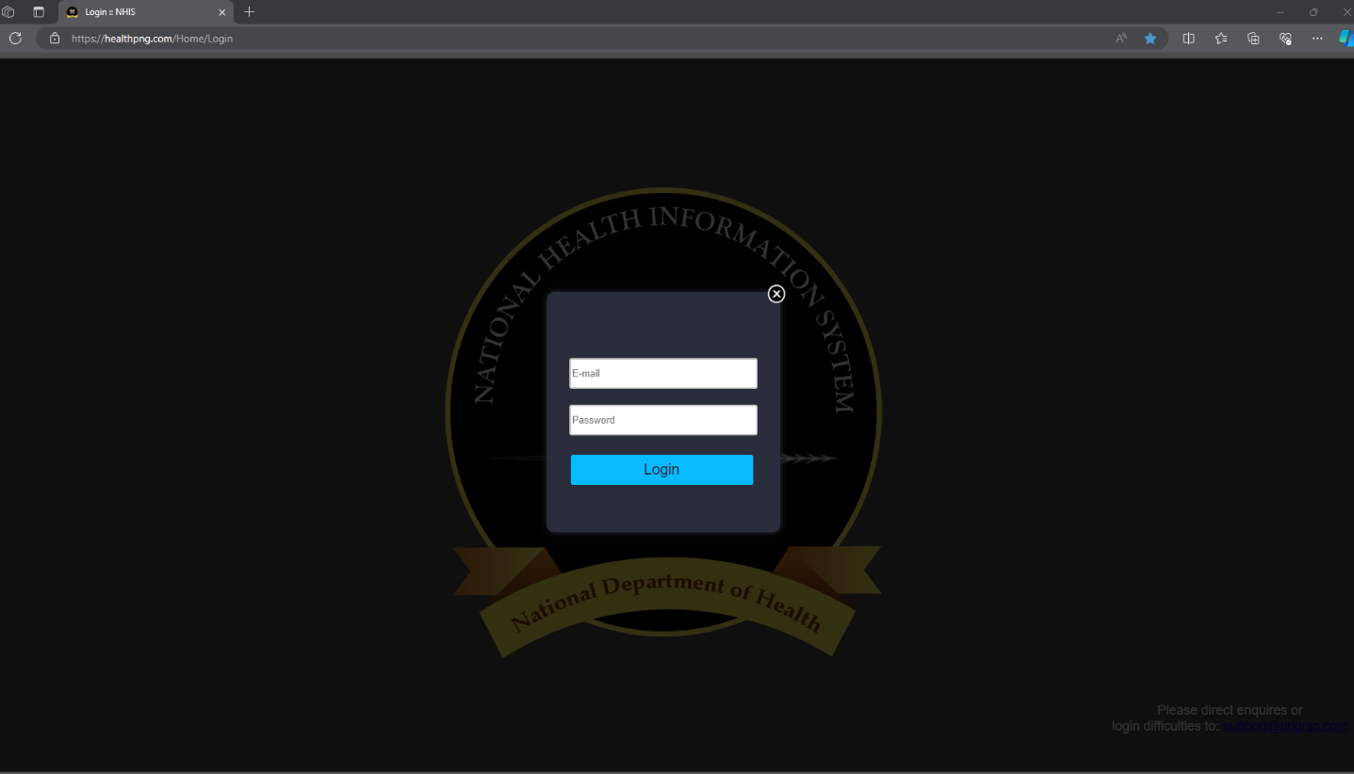
- https://healthpng.com/Home/Login
Figure. 1.2. Login interface

2. Identifying Required Data:
- Familiarize yourself with the specific reporting requirements set by CHSPNG Head Office. This will determine the type of data you need to retrieve from eNHIS.
- The reporting requirements might specify data categories like demographics, service utilization (types of services provided), specific health indicators (e.g., malaria cases), or a combination of these.
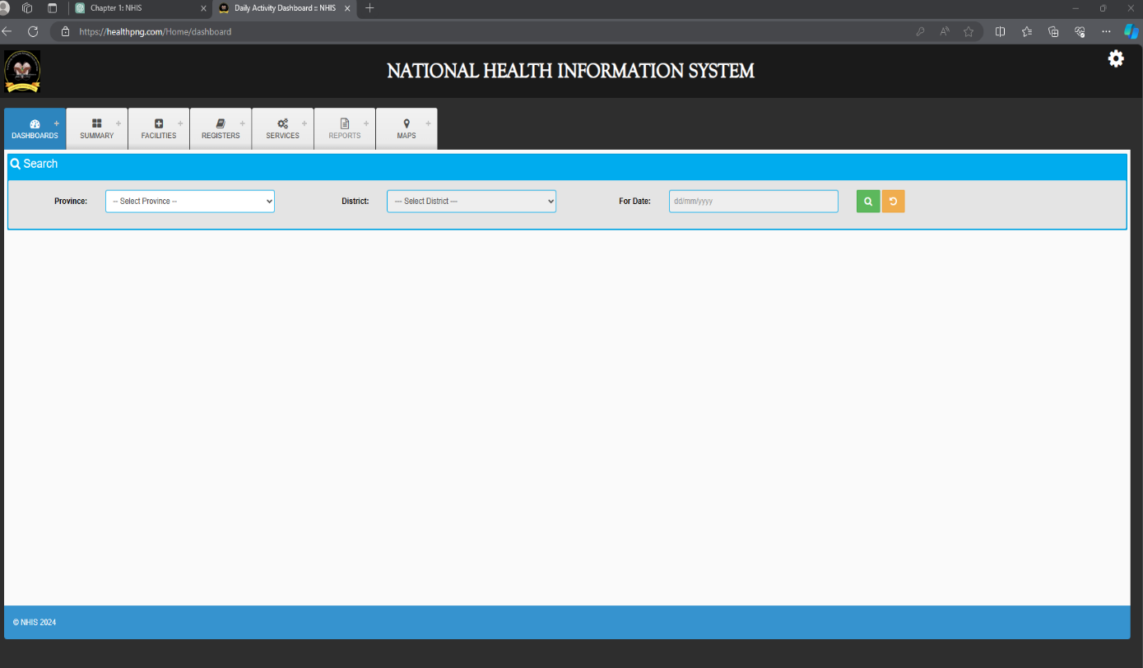
Figure. 1.3 Dashboard Interface

3. Navigating eNHIS for Data Retrieval:
- Once logged in, explore the eNHIS interface to locate the relevant sections or modules that house the data you need.
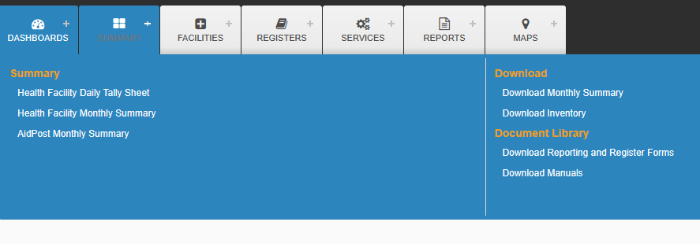
Figure. 1.4 Navigating eNHIS Dashboard

4. Filtering and Extracting Data:
- Depending on the complexity of the report, you might need to filter data based on specific criteria like date range, location (your health agency or facility), or program participation.
- Utilize the eNHIS functionalities to export the retrieved data into a usable format. This could be exporting to a spreadsheet program (e.g., Microsoft Excel) or downloading a pre-formatted report from the system, if available.

5. Data Analysis (Optional):
- While data submission is the primary task, your health agency might choose to perform some basic data analysis on the retrieved information.
- This could involve calculating totals, percentages, or identifying trends within your jurisdiction to gain a deeper understanding of the data before submission.

6. Data Submission to CHSPNG National Secretariate Office
- Follow the designated procedure outlined by CHSPNG for submitting the retrieved data. This might involve:
  - Uploading the data through a secure online portal specifically designed for report submission.
  - Using a separate offline reporting format provided by CHSPNG, which you would need to fill out with the retrieval data using the data template.
  - Sending the report electronically or by mail if that's the specified method.
7. Documentation and Record Keeping:
- Maintain a record of the data retrieval process, including the date, type of data retrieved, filters applied (if any), and the format used for submission.
- This documentation can be helpful for future reference or troubleshooting any discrepancies that might arise.

Additional Tips:
- If you encounter any difficulties while navigating eNHIS or retrieving data, seek assistance from the eNHIS technical support team or your CHSPNG IT & M&E team.
- Familiarize yourself with any data quality checks or validation procedures implemented by CHSPNG to ensure your submitted data meets their standards.

By following these steps and maintaining good practices, you can efficiently retrieve data from eNHIS for your health agency's reports and contribute valuable information to CHSPNG for improved public health monitoring in Papua New Guinea.

Hands-on Exercise: Retrieving Data from eNHIS for Monthly Reporting
Scenario: You are a health worker at your local Health Agency health centre, health facility, or aid post clinic in your service area. It's time to submit your monthly report to CHSPNG Head Office for the month of May 2024. This exercise will guide you through retrieving data from the eNHIS platform (simulated environment) for your report.
Important Note: Due to data privacy and security restrictions, this exercise will use a simulated eNHIS environment with sample data.

Wrap-up:
This exercise provided a hands-on experience in utilizing the eNHIS platform (simulated environment) to retrieve data for your monthly Health Agency report. Remember, the actual interface and functionalities might differ slightly in the real eNHIS system.
Additional Notes:
- Throughout the exercise, your facilitator will be available to answer any questions and provide additional guidance.
- For real-world monthly reporting scenarios, always refer to the specific instructions and reporting requirements set forth by CHSPNG Head Office. They might provide a pre-defined monthly reporting template or have specific guidelines for data retrieval and submission.

By completing this exercise, you have gained practical skills in navigating eNHIS to retrieve data relevant to your monthly reporting needs. This will be valuable for your future work in contributing essential health data to CHSPNG for improved public health monitoring in Papua New Guinea.

Summary
The eNHIS Data Capture Workshop is to equip Christian Health Agency (CHA) personnel with the essential skills to effectively contribute to Papua New Guinea's public health efforts. This workshop dives into the eNHIS system, the electronic platform used to collect vital health data across the country. Participants will gain a comprehensive understanding of why capturing and submitting accurate data through eNHIS is crucial. The workshop will explore the different sections of the eNHIS online pothole, which categorizes health information into demographics, service utilization, and other relevant areas.

Data capture template for Christian Health Services from Papua New Guinea helps organize to retrieve specific health data from Health Agency, Facilities, Aid Post, Health Centres, clinics. The template has sections for data category, indicators, source within eNHIS, definition, and how to capture the data. By using the template, healthcare workers can efficiently collect and manage accurate health information within eNHIS.
This improves organization, saves time, reduces errors, and fosters collaboration through hands-on exercises, participants will learn how to navigate the eNHIS system and correctly enter data using various field types, such as text, numbers, and dates. This ensures consistency and minimizes errors in the collected data. The workshop will also emphasize best practices for maintaining data quality and completeness, guaranteeing the information submitted reflects the true picture of healthcare needs within each health agency’s jurisdiction.

Furthermore, the workshop will address common challenges faced during data capture and submission, equipping participants with the knowledge to troubleshoot any issues that may arise. By the end of the workshop, health centres/agencies will be confident in utilizing eNHIS to its full potential, contributing to a more efficient and accurate health information system for Papua New Guinea.

Data Drives Decision-Making: | - Reliable health data is crucial for effective healthcare delivery and informed public health decisions.
eNHIS: Transforming Health Information Management: | - eNHIS is a centralized electronic system that improves data accuracy, efficiency, and accessibility compared to paper-based methods.
Accurate Data Capture Matters: | - Inaccurate data in eNHIS can lead to misinformed decisions, hinder tracking of health trends, and compromise program implementation, ultimately affecting the effectiveness of M&E practices.
Data Capture Templates: Streamlining the Process | - Standardized data capture templates within CHSPNG ensure consistent data collection across facilities. These templates define data categories (e.g., demographics), specific variables (e.g., age, gender), and data sources within eNHIS

By equipping healthcare workers with the knowledge and skills for accurate data capture/retrieval from eNHIS, this session contributes to a more efficient and informed healthcare hierarchy system within CHSPNG and other relevant authorities, ultimately leading to better health outcomes for the population and country as whole.

This enhanced data collection system allows Christian Health Services PNG (CHSPNG) to monitor health trends more effectively. With this valuable information, CHSPNG can identify priority public health concerns and make informed decisions on resource allocation and program development. Ultimately, a well-functioning eNHIS system empowers our Health Agencies to play a vital role in strengthening healthcare delivery and improving health outcomes for all citizens of Papua New Guinea.

